**Waveform**

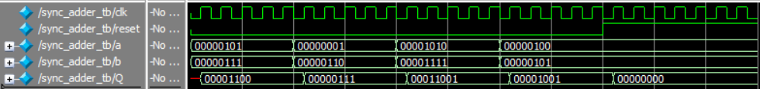

**Verilog Code**

`timescale 1ns / 1ns

module sync_adder_tb;

//signals needed to test functionality of sync adder

logic clk;

logic reset;

logic [7:0] a;

logic [7:0] b;

logic [7:0] Q;

//creating a sync adder and connecting signals

sync_adder DUT(

.clk(clk),

.reset(reset),

.a(a),

.b(b),

.Q(Q)

);

initial // initial block runs only once

begin

clk = 0;

//Simple test

a = 5;

b = 7;

reset = 0;

#10

//self-checking

a = 1;

b = 6;

reset = 0;

#10

if (Q != 7) $display("1+6 failed");

//self-checking

a = 10;

b = 15;

reset = 0;

#10

if (Q != 0) $display("10+15 is not 0!");

//Add code for 4+5=9 -------------------------------

//self-checking

a = 4;

b = 5;

reset = 0;

#10

if (Q != 9) $display("4+5 failed!");

//--------------------------------------------------

//Add code to test reset ---------------------------

//testing reset

a = 4;

b = 5;

reset = 1;

#10

if (Q != 0) $display("reset failed!");

//--------------------------------------------------

#5

$stop;

end

always

#1 clk = ~clk;

endmodule